A1-D1: Identifying Business Needs and Framing the Problem
Francis Lee | tli174 | Spark New Zealand Limited

1. Company Overview
Spark New Zealand Limited is a publicly listed telecommunications and digital services company operating across consumer, business and public-sector markets. Mobile and broadband form its core connectivity business, alongside cloud, security and managed digital services. In FY25, Spark reported revenue of NZ$3,725 million and mobile service revenue of NZ$987 million. Under SPK-30, core connectivity contributes approximately 80% of group gross margin (Spark New Zealand Limited, 2025a, pp. 3-5; Spark New Zealand Limited, 2025b).
Spark describes its purpose as "To help all of New Zealand win big in a digital world" and its FY30 ambition as "It's better with Spark" (Spark New Zealand Limited, 2025a, pp. 14-15). The company does not publish separate statements called vision and mission. For this analysis, the purpose represents Spark's intended contribution, while the SPK-30 ambition and strategic choices describe how it intends to achieve that contribution by leading core connectivity through better customer and network experiences.

2. Products and Services
Spark provides mobile and broadband services, devices and connectivity for consumer and business markets. Its portfolio also covers cloud, security, collaboration, managed services, Internet of Things solutions and digital self-service. This assignment focuses on Spark-branded consumer mobile pay-monthly and prepaid plans. Customers can use MySpark, the Spark website, retail stores or contact centres to inspect account information, compare available plans and decide whether to change or retain a plan (Spark New Zealand Limited, 2025a; Spark New Zealand Limited, n.d.).

3. Stakeholder Map
Figure 1 places existing, prospective and recently lost customers at the centre of the plan-value decision. Customers interact directly with MySpark, retail advisers and contact-centre advisers. The internal stakeholders are the mobile proposition, marketing/CRM, analytics, service operations, finance, and data/privacy/legal teams. Suppliers and technology partners support delivery. The Commerce Commission, investors, communities and competitors contribute regulatory, accountability and market pressure. The arrows show service/experience, data/decision, and regulation/pressure/accountability relationships (Spark New Zealand Limited, 2025a, pp. 24, 29, 128-129; Commerce Commission, 2026).
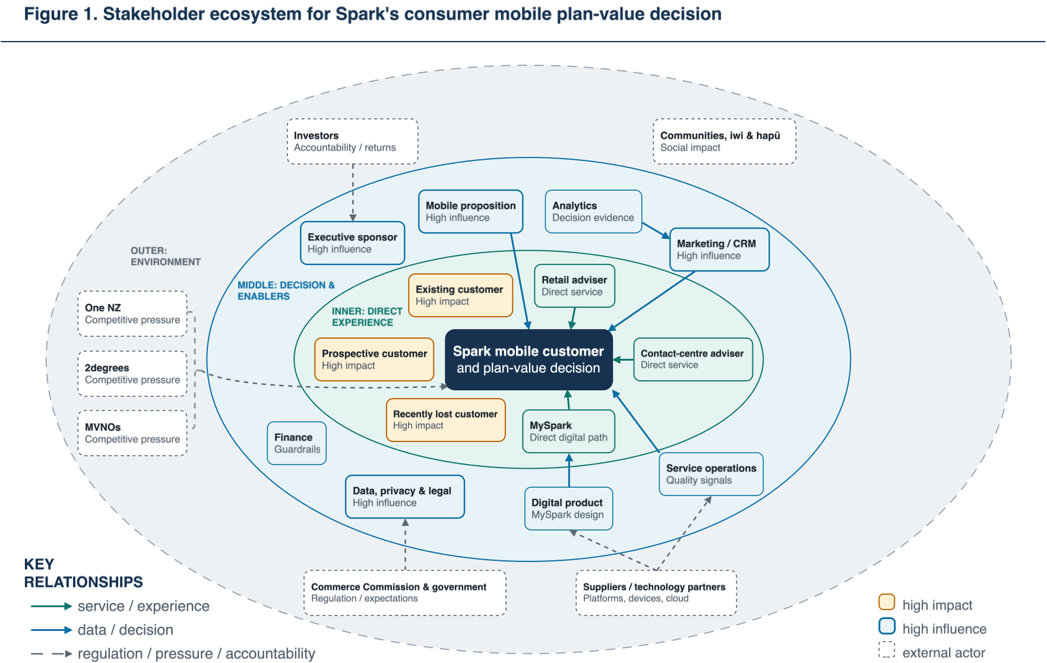
Figure 1. Stakeholder ecosystem for Spark's consumer mobile plan-value decision.

4. Industry Analysis
New Zealand consumer mobile is a mature, concentrated market. In 2025 it comprised 6.9 million connections and NZ$3.28 billion of retail revenue; group connection shares were Spark 38%, One NZ 37%, 2degrees 22% and MVNOs 3% (Commerce Commission, 2026, pp. 15-16, 213-216).
Force | Assessment | Key evidence | Strategic implication
Rivalry | High | Three network operators compete with a growing MVNO segment; Spark and One NZ are separated by one percentage point of connections (Commerce Commission, 2026, pp. 213-216). | In a mature market, Spark's performance depends on retention and share capture.
Buyer power | Medium-high | Customers can compare several brands, but half of recent mobile switchers reported issues and some consumers were deterred from switching (Commerce Commission, 2025a). | Customers need a transparent plan-fit decision with little effort.
New entrants | Medium | Full network entry faces spectrum and infrastructure barriers, while MVNO and bundle-led models lower retail-entry barriers (Commerce Commission, 2026, pp. 15-16). | Spark needs to differentiate through customer value rather than network scale alone.
Substitutes | Medium | Wi-Fi and over-the-top services reduce reliance on traditional voice and SMS, but growing mobile-data use keeps connectivity essential (Commerce Commission, 2026). | Service relevance, bundles and customer experience remain defensible differentiators.
Supplier power | Medium | Spectrum, towers/backhaul, devices, cloud platforms and specialised network equipment are concentrated inputs; Spark partly offsets this through scale and partnerships (Spark New Zealand Limited, 2025a). | Supplier and partner governance matters, although it sits outside the selected customer process.
High rivalry and buyer power make network quality insufficient on its own to secure retention. Spark also needs to make customer-specific value clear before avoidable exit intent hardens.
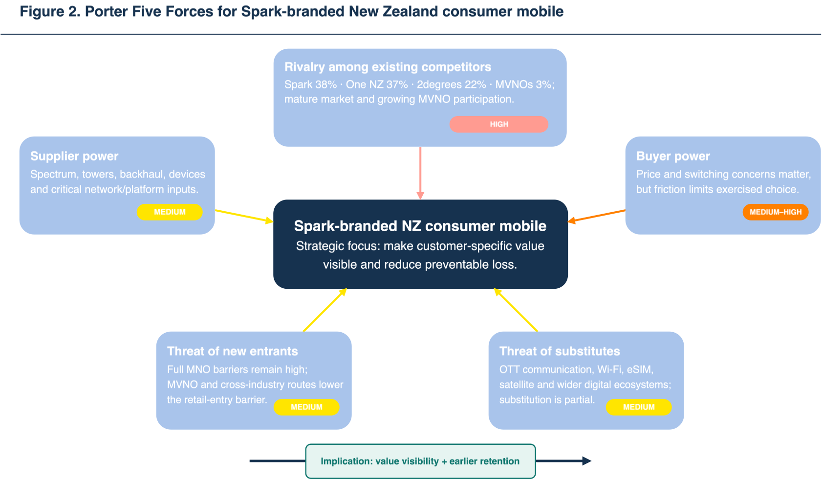
Figure 2. Porter Five Forces for Spark-branded New Zealand consumer mobile.

5. Strategy
Spark's SPK-30 strategy fits Porter's broad-differentiation position more closely than cost leadership. The strategy seeks to lead in core connectivity through better network and customer experiences while simplifying and optimising activities beyond the core. This choice matters commercially because mobile and broadband contribute approximately 80% of group gross margin (Spark New Zealand Limited, 2025b).
In mobile, SPK-30 focuses on the right offer for the right customer at the right time, loyalty recognition and mobile-broadband bundling. If the plan-review journey does not clearly translate usage, spend and service quality into an explainable fit decision, it weakens Spark's differentiation and increases retention risk (Spark New Zealand Limited, 2025b).

6. Value Chain
Figure 3 applies Porter's value chain to consumer mobile. The support activities cover procurement, technology/data/AI, people, governance/risk/privacy/cyber and sustainability. They enable the primary flow through access inputs, network operations, activation, marketing and ongoing engagement. The selected process boundary lies between Marketing & sales and Engagement & retention. At this point, usage and spend data should support a timely and transparent plan decision. Performance is linked to retained connections, ARPU, mobile connection share and customer trust (INFOSYS 704 Teaching Team, 2026b, slides 11-12; Spark New Zealand Limited, 2025b).
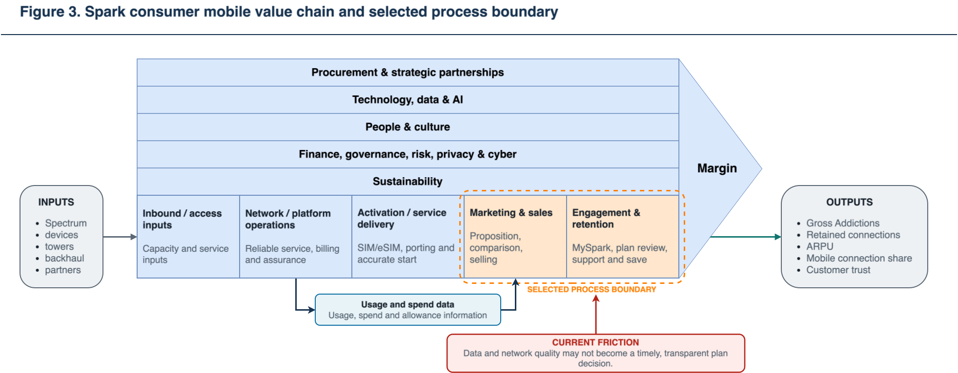
Figure 3. Spark consumer mobile value chain and selected process boundary.

7. AS-IS Rich Picture
Figure 4 shows the relationships among customers, MySpark, advisers, Spark teams, usage/spend data, network and service signals, regulators and competitors. The practical gap is that strong connectivity and available customer data do not automatically produce a timely and transparent plan-fit decision. Limited feedback may also restrict learning from stay, change and exit outcomes. The questions are analytical prompts, not participant quotations. The picture uses public evidence and does not claim direct observation of Spark's internal workflow (Commerce Commission, 2024, pp. 5-6; Commerce Commission, 2025b, pp. 7-9; Spark New Zealand Limited, n.d.).
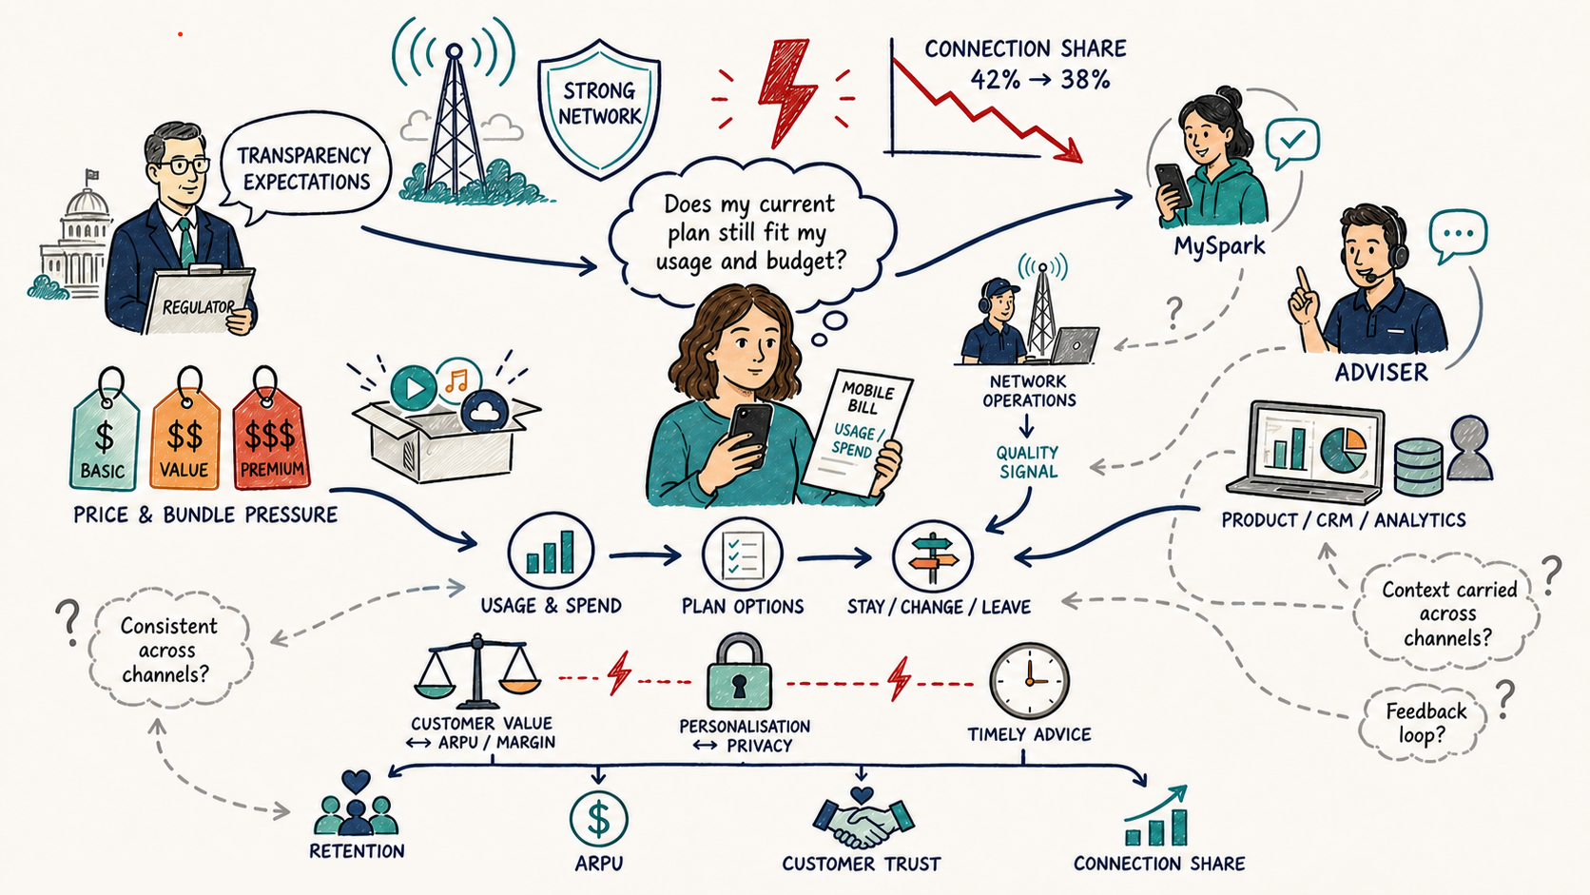
Figure 4. Rich picture of Spark's consumer mobile share and plan-value system.

8. Business Needs
The four business needs are ranked by their proximity to the selected process, strategic relevance and capacity to influence customer outcomes:
Priority | Business need | Evidence/analysis link | Justification
1 | Provide a timely and transparent plan-fit decision before avoidable exit intent hardens. | Five Forces, value-chain boundary and Rich Picture tension. | Directly addresses retention risk in a high-rivalry, high-buyer-power market.
2 | Deliver consistent, explainable and privacy-respecting support across MySpark, web, retail and contact-centre channels. | Stakeholder map and cross-channel Rich Picture. | Makes Spark's data and service capability understandable to customers.
3 | Capture review completion, acceptance/rejection and subsequent outcomes in a closed learning loop. | Rich Picture feedback gap and value-chain performance links. | Provides evidence for process refinement and keeps analytical assumptions separate from observed facts.
4 | Protect ARPU, contribution margin, privacy and customer trust while serving pay-monthly and prepaid needs. | SPK-30 strategy, governance support activities and regulatory expectations. | Protects against retention tactics based on indiscriminate discounting or inappropriate data use.

9. Problem Type
The problem is primarily strategic and competitive because it concerns Spark's position in a core market. Group mobile connection share fell from 42% in June 2022 to 38% in June 2025, while SPK-30 aims to lead in core connectivity (Commerce Commission, 2026, pp. 213-216; Spark New Zealand Limited, 2025b). A clearer plan-value decision could help protect customer relationships against rival and MVNO offers. Operational hand-offs, organisational ownership and financial guardrails affect execution, but they remain secondary mechanisms or constraints rather than the main problem category.

10. Dysfunctional Process
The selected process is the Spark-branded New Zealand individual-consumer mobile plan-value review. It begins when a customer recognises a possible mismatch or initiates a review. It ends when the customer receives enough information to decide whether to stay, change, decline or exit. The analysis covers usage/spend visibility, plan comparison, digital and assisted support, and the final plan decision. It excludes network remediation, wholesale/MVNO operations, enterprise or SME sales, and undisclosed CRM, eligibility or adviser rules. These excluded activities are not treated as observed facts.
Publicly observed evidence | Indicated dysfunction | Linked business need
The Commerce Commission's 2024 review described Spark's Made For You Review as providing usage/spend information and a proactive best-plan recommendation. A later review, covering 1 July 2024-30 June 2025, found that annual summaries had paused and that the expected replacement would omit embedded usage data and right-planning (Commerce Commission, 2024, pp. 5-6; Commerce Commission, 2025c; Gelling, 2025). | The independently tested plan-transparency support was not available continuously across the latest completed review periods. | Need 1: timely, transparent plan-fit decision.
Spark's current help page directs customers to sign in, open the current plan, choose Change plan, browse plans and benefits, then select and confirm. It does not document a 12-month usage/spend comparison, allowance-gap calculation or personalised best-fit conclusion (Spark New Zealand Limited, n.d.). | The documented journey is initiated by the customer and organised around options; it does not provide an explicit suitability conclusion. | Needs 1-2: transparent fit and consistent channel support.
The Commerce Commission guidelines call for at least 12 months of usage/spend, an at-a-glance comparison with allowances, a prompt toward more appropriate options and an easy route to change plans (Commerce Commission, 2025b, pp. 7-9). | Public plan-change documentation does not show the regulator's complete decision-support benchmark. This is an evidence gap, not a finding of non-compliance. | Needs 1-4: explainability, consistency and trust guardrails.
Together, the reports and public instructions support a dated diagnosis of the customer-facing journey and its documentation. This follows the specification's reports/data evidence route. The evidence does not reveal hidden MySpark screens, adviser practice or internal CRM rules, and it does not establish a causal contribution to the decline in connection share.

11. SMART Problem Statement
Spark's group mobile connection share fell from 42% in June 2022 to 38% in June 2025, while its publicly documented customer-initiated plan-review path does not demonstrate a consistent, timely and transparent plan-fit decision. By 30 June 2027, Spark should validate through a controlled pilot whether improving that process can reduce 90-day avoidable churn by at least 15%, achieve at least 60% review completion and at least 20% eligible-recommendation acceptance, without material deterioration in ARPU, contribution margin or customer trust.
These thresholds are proposed stage-gate criteria for a pilot. They are not Spark commitments, forecasts or validated internal baselines.

12. Problem-Framing Framework
Customer Journey Mapping (CJM) is the primary framing framework for this problem. It captures journey stages, digital and assisted touchpoints, customer actions, decision questions, pain points, opportunities and channels (INFOSYS 704 Teaching Team, 2026c, slide 24; INFOSYS 704 Teaching Team, 2026a, slide 5). This customer-level view is more useful than an environment-only framework for locating where plan-fit evidence becomes unclear or inconsistent.
CJM links the prioritised business need and selected dysfunctional process to the issue tree. It defines the experience boundary, while MECE decomposition and testable hypotheses direct the next stage of evidence collection. Rasiel and Friga's fact-based approach to problem definition, structured decomposition and hypothesis-led analysis supports this sequence (2001, Chapter 1).
The analytical persona is a value-conscious Spark pay-monthly or prepaid mobile customer who wants to decide confidently whether the current plan still fits actual usage, budget and preferences. The persona comes from the defined scope and public evidence, not demographic research or participant quotations.

Evidence-bounded current-state journey
Journey element | 1. Trigger | 2. Inspect | 3. Compare | 4. Seek help/decide | 5. Act | 6. Reflect
Customer action | Notice a possible mismatch, bill/usage event, prompt or rival offer. | Review usage, spend and allowances. | Compare the current plan with alternatives. | Self-select or request advice. | Stay, change, decline or port out. | Assess whether fit and value improved.
Touchpoint/channel | Bill/usage event, competitor media or a potential owned prompt; public sources do not establish Spark's current trigger. | MySpark app/web and bill. | MySpark, Spark website and competitors' public pages. | MySpark/web, retail or contact centre. | MySpark, assisted channel or porting ecosystem. | Confirmation, MySpark and later bill.
Decision question/evidence gap | Should the plan be reviewed? Trigger logic is not public. | What do 12 months of usage, spend and allowances imply? | Which option is demonstrably more suitable? The public path is option-led. | What evidence supports the advice? Public sources do not describe adviser practice. | What changes, when and on what terms? Selection/confirmation is documented. | Did the decision improve fit? Post-change evaluation is not public.
Opportunity | Consented, evidence-based trigger. | Explainable fit signal. | Normalised comparison. | Shared recommendation record. | Low-friction fulfilment. | Benefit check and outcome capture.
The journey combines Spark's public help path with the Commerce Commission's transparency benchmark. Channel behaviour that has not been verified remains an evidence gap rather than a current-state finding (Commerce Commission, 2025b, pp. 7-9; Spark New Zealand Limited, n.d.).

Porter's Five Forces explains the external competitive environment, while the issue tree decomposes possible causes. Neither provides CJM's cross-channel view of the customer decision.

13. Issue Tree
Figure 5 starts with the identity Spark group connection share = Spark group connections / total measured market connections. Branch A covers the Spark-connection numerator, while Branch B covers the market denominator and reporting perimeter. Within Branch A, end connections equal opening connections plus gross additions minus losses. The path A -> A2 -> A2.1 is selected because it best matches the public plan-transparency evidence and has a controllable process boundary. It remains an analytical focus rather than a proven root cause. Lecture 4 and The McKinsey Mind provide the basis for the MECE and hypothesis-led structure (INFOSYS 704 Teaching Team, 2026c, slides 8-14; Rasiel & Friga, 2001, Chapter 1).
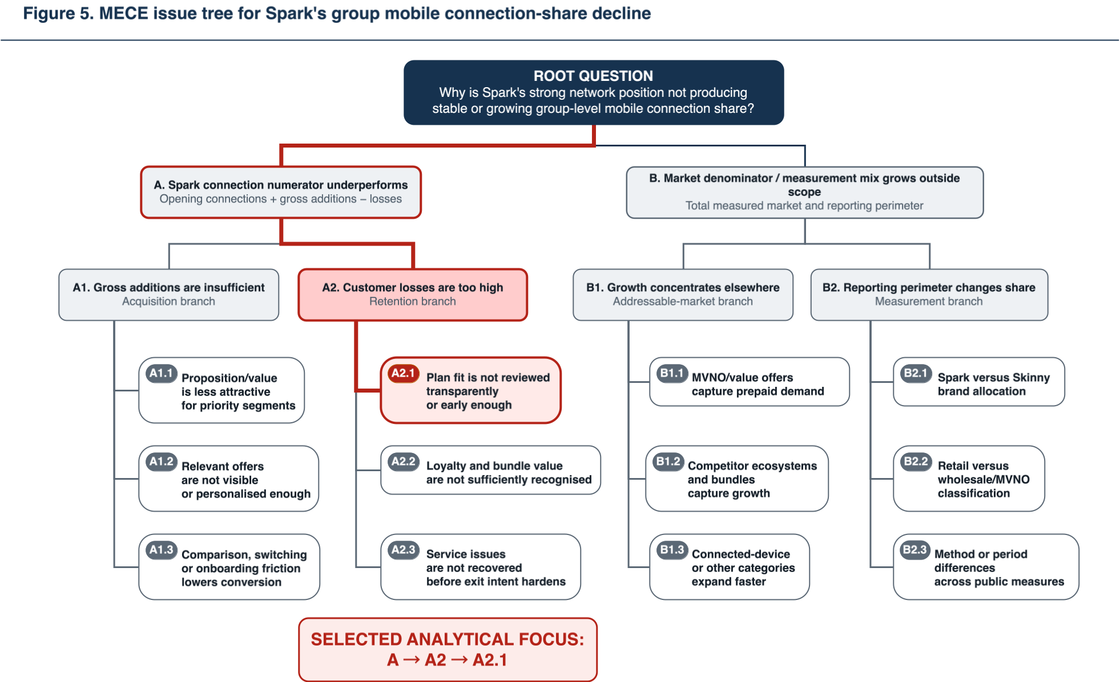
Figure 5. MECE issue tree for Spark's group mobile connection-share decline.

14. Testable Hypotheses
Each of the six hypotheses comes from a leaf in the issue tree. H1 and H2 receive priority because they directly test the selected plan-value process. H3-H6 examine credible alternative explanations. These are pre-test propositions, not claims about Spark's current performance. The evidence requirements and falsification criteria apply the hypothesis-driven discipline described by Rasiel and Friga (2001, Chapter 1).
ID/tree leaf | Testable hypothesis | Evidence required | Falsified if
H1 / A2.1 | Among equivalent eligible review starters, an explainable fit conclusion reduces 90-day avoidable churn by at least 15% versus an equivalent-information comparator. | Eligibility, assignment, exposure, arm equivalence, 90-day churn and guardrails. | An adequately powered estimate is below 15%, shows no improvement, or breaches a guardrail.
H2 / A2.1 | Intervention before a validated at-risk milestone produces lower 90-day avoidable churn than intervention after customer contact or port-out intent. | Trigger definition, timestamps, comparable risk, treatment timing and churn. | The adjusted early-treatment cohort does not outperform the late-treatment cohort.
H3 / A2.1 | Among voluntary prepaid losses, price/value is the largest valid single loss-reason category. | Complete loss-reason taxonomy, prepaid exit data and missingness rate. | Price/value is not largest or missing reasons prevent inference.
H4 / A2.2 | Explicit loyalty recognition raises eligible-offer acceptance by at least 10% without breaching the contribution-margin guardrail. | Controlled offer exposure, tenure, acceptance and contribution margin. | Relative lift is below 10% or the margin guardrail fails.
H5 / A2.1 | Customers who repeat account context across channels have a review-completion rate at least 10 percentage points lower than customers whose context persists. | Journey, transfer, repeated-context and completion data. | The adjusted completion gap is below 10 percentage points.
H6 / A2.1 vs A2.3 | Among validated avoidable-churn cases, plan-fit/value reasons account for more losses than network-quality reasons. | Standardised exit reasons, complaints, network-quality and churn data. | Plan-fit/value does not exceed network quality as a valid reason category.

15. AS-IS Process Model
Figure 6 was created in SAP Signavio. It models the customer-initiated plan-value review across the customer, MySpark/digital, retail/contact-centre and Spark service participants. The model includes usage/spend retrieval, plan comparison, advice, selection/confirmation, and stay, change or port outcomes. Section 10's dysfunction appears at the decision points for sufficient fit evidence, cross-channel hand-offs and outcome capture. Internal activities that cannot be observed from public evidence remain at a high level. The result is an evidence-bounded AS-IS analytical model, not a Spark-validated internal process.
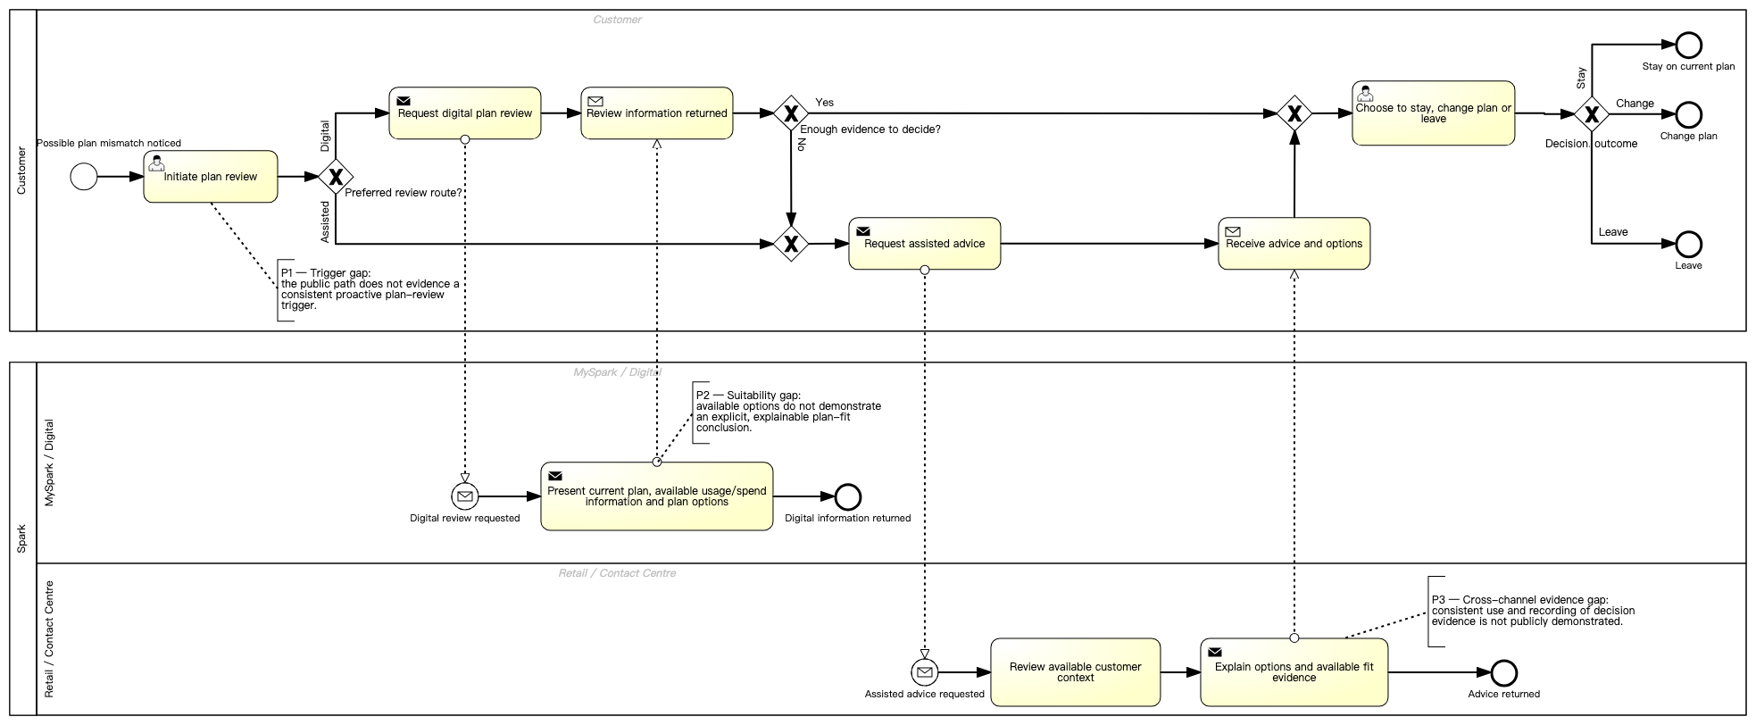
Figure 6. SAP Signavio AS-IS model for the consumer mobile plan-value review.

References
Commerce Commission. (2024, November 27). Mobile transparency final progress review: Open letter. https://www.comcom.govt.nz/__data/assets/pdf_file/0031/363397/Mobile-Transparency-Final-Progress-Review-Open-letter-27-November-2024.pdf
Commerce Commission. (2025a, March 20). ComCom calls for better switching for consumers. https://www.comcom.govt.nz/news-and-media/news-and-events/2025/comcom-calls-for-better-switching-for-consumers/
Commerce Commission. (2025b, November 13). Mobile transparency guidelines. https://www.comcom.govt.nz/assets/Documents/review-of-consumer-mobile-bills/Mobile-Transparency-Guidelines-13-November-2025.pdf
Commerce Commission. (2025c, October 2). Spark, 2degrees and One NZ stall on billing transparency. https://www.comcom.govt.nz/news-and-media/news-and-events/2025/spark-2degrees-and-one-nz-stall-on-billing-transparency/
Commerce Commission. (2026). 2025 telecommunications monitoring report: Pūrongo aroturuki torotoro waea 2025. https://www.comcom.govt.nz/assets/Uploads/2025-Telecommunications-Monitoring-Report-29-June-2026.pdf
Gelling, N. (2025, October 1). It's getting harder to tell which mobile plan you should be on. Consumer NZ. https://www.consumer.org.nz/tech/phones-and-watches/mobile-phones/it-s-getting-harder-to-tell-which-mobile-plan-you-should-be-on
INFOSYS 704 Teaching Team. (2026a). Lab 2 content [PowerPoint slides]. University of Auckland.
INFOSYS 704 Teaching Team. (2026b). Week 1: Lecture 3: Business analysis and process management [PowerPoint slides]. University of Auckland.
INFOSYS 704 Teaching Team. (2026c). Week 2: Lecture 4: Problem framing, hypothesis development and AS-IS analysis [PowerPoint slides]. University of Auckland.
Rasiel, E. M., & Friga, P. N. (2001). The McKinsey mind: Understanding and implementing the problem-solving tools and management techniques of the world's top strategic consulting firm. McGraw-Hill.
Spark New Zealand Limited. (n.d.). Change mobile plan. Retrieved August 4, 2026, from https://www.spark.co.nz/help/mobile/manage/change-mobile-plan
Spark New Zealand Limited. (2025a). Annual report FY25. https://www.spark.co.nz/content/dam/spark/documents/pdfs/governance/FY25_Annual_Report.pdf
Spark New Zealand Limited. (2025b, September 11). Spark releases FY30 strategy and update on Chair succession. NZX. https://www.nzx.com/announcements/458551

